Experiment 5A: Containerize a Flask Application which prints Hello Beautiful World using
Dockerfile.Also push the image to central registry ie; Docker Hub.
STEP: First Install Docker.
STEP: In Desktop create a folder pythonDocker.
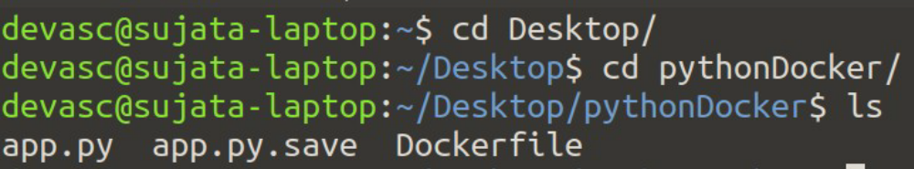
STEP: Create Dockerfile:
FROM python → Tells which base image you want
MAINTAINER "Sujata Oak" → Who is the author who has written dockerfile
RUN pip install flask → RUN command is used to run a command inside python image
CMD ["python","app.py"]
COPY app.py /app.py
STEP: Create a Flask Application
from flask import Flask → Import flask module
app = Flask(__name__) → Flask Constructor takes the name of current module
(__name__) as argument
@app.route("/") → The route() function of the flask class is a decorator which tells
the application which URL should call the associated function.
def hello(): → In this eg, “/” URL is bound with hello function. Hence
when the homepage of web server is opened in browser the
output of this function will be rendered.
return "Hello Beautiful World!"
if __name__ == "__main__": → run method of flask class run the application on local
development server.
app.run(host='0.0.0.0')
STEP: Build a Docker Image
STEP: List images:
STEP: RUN
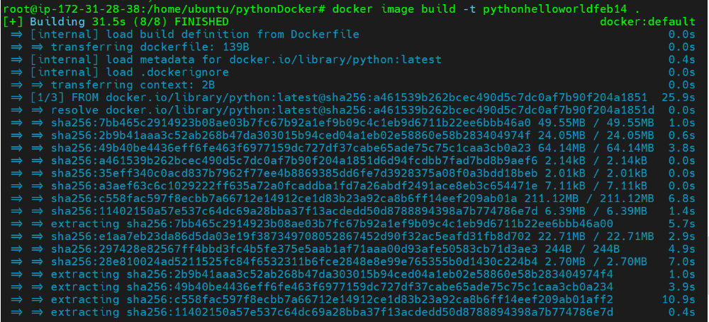
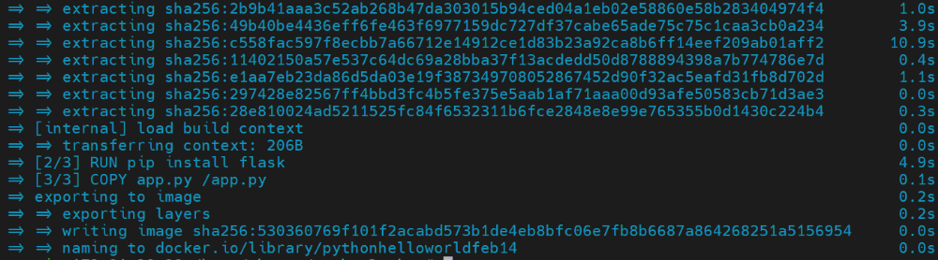
STEP: List images:
STEP: RUN the Docker Image:
STEP: To check the status of container:
STEP: Deploy the flask application:
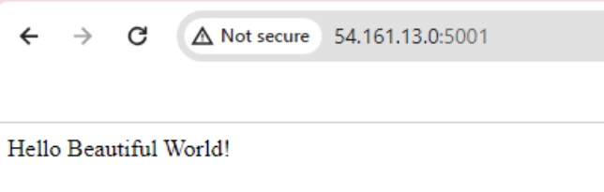
STEP: Push Image to central Registry ie; Docker hub
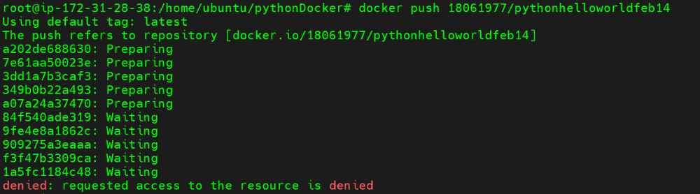
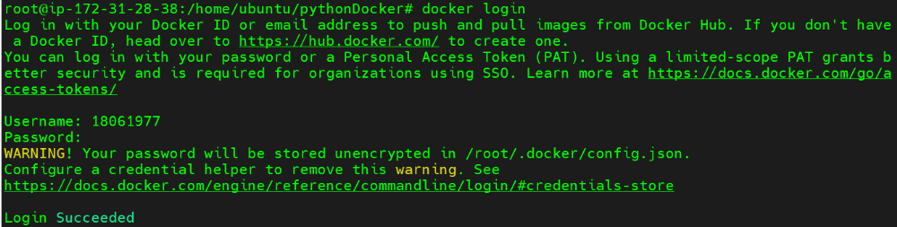
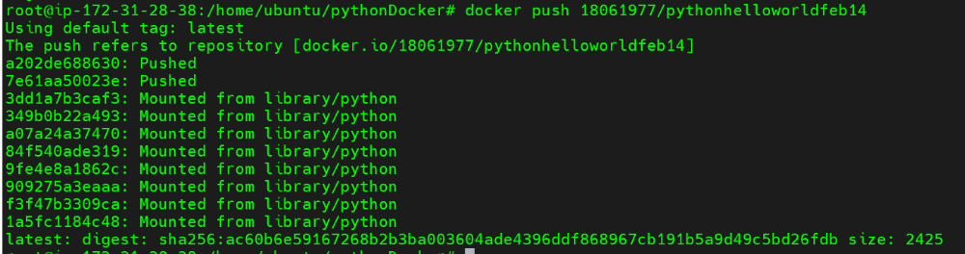
Goto Docker hub, Refresh page
